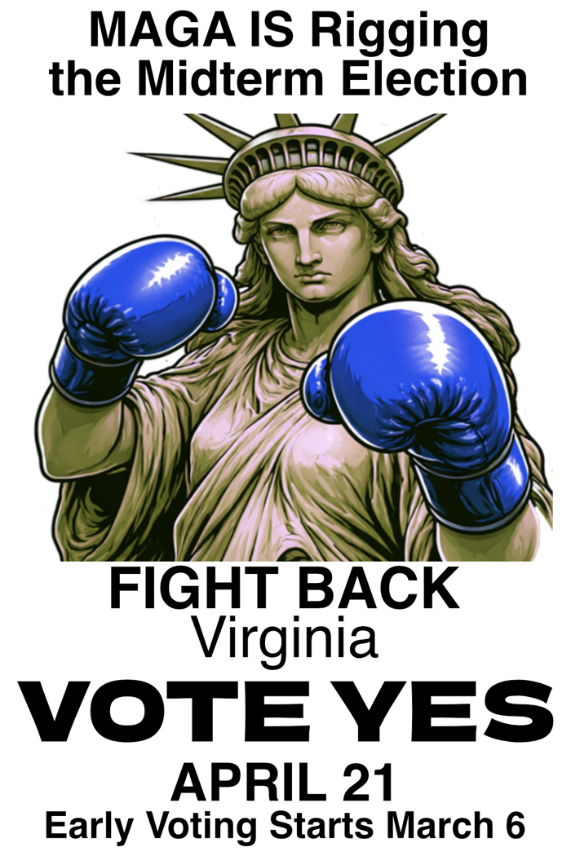
Donald Trump is rigging the upcoming midterm elections to lock in his power— demanding that Red states redistrict to ensure more Republican seats in Congress.
Virginia is fighting back. Governor Spanberger and the General Assembly placed our redistricting amendment on the ballot to protect Virginia voters and the country.
Working families are facing economic strain, rising health care costs, and weakened public services. Our communities are being terrorized by ICE.
The 2026 congressional election may be the only meaningful check on the MAGA agenda.
Vote YES April 21 – early voting March 6 More info – voteYES.us

Donald Trump is rigging the upcoming midterm elections to lock in his power— demanding that Red states redistrict to ensure more Republican seats in Congress.
Virginia is fighting back. Governor Spanberger and the General Assembly placed our redistricting amendment on the ballot to protect Virginia voters and the country.
Working families are facing economic strain, rising health care costs, and weakened public services. Our communities are being terrorized by ICE.
The 2026 congressional election may be the only meaningful check on the MAGA agenda.
Vote YES April 21 – early voting March 6 More info – voteYES.us

